Orphan models audit
Models that appear only once or twice on the map (Chat City, its islets and the fog island; the continent is not counted). Count = how many times the model is placed on the whole map; Where = how many of them in each zone. The models are sorted by zone: a model placed in two zones is listed under both.

Summary
155 models are used only once or twice: 114 used once, 41 used twice, out of 290 different models placed.
- APARTMENT: 10 models
- CIVIC: 41 models
- COMMERCIAL: 7 models
- DESERT: 6 models
- DOWNTOWN: 10 models
- FARM: 5 models
- FOG: ARMY BASE: 2 models
- FOG: NUCLEAR PLANT: 1 models
- INDUSTRIAL: 43 models
- NATURE: 7 models
- POOR: 6 models
- PRISON: 1 models
- QUARTER: 18 models
- SEA: 3 models
- SUBURBAN: 9 models

APARTMENT (10)
Picture | Model | Where | Count
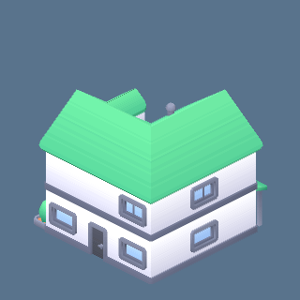 | building-type-f.glb | APARTMENT:1, SUBURBAN:1 | 2
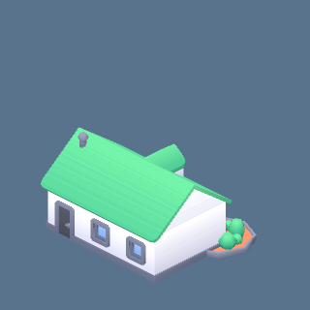 | building-type-g.glb | APARTMENT:1, SUBURBAN:1 | 2
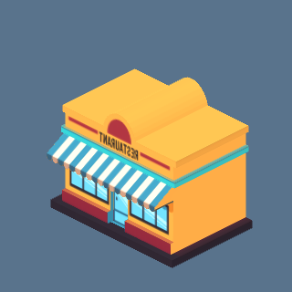 | carto.glb: restaurant | APARTMENT:1 | 1
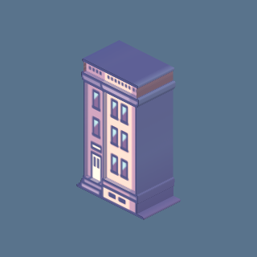 | carto.glb: town0 | APARTMENT:1 | 1
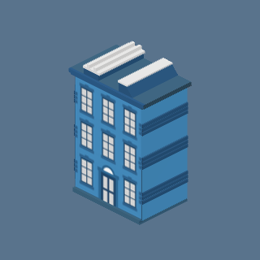 | carto.glb: town3 | APARTMENT:1 | 1
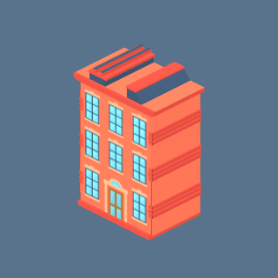 | carto.glb: town4 | APARTMENT:1 | 1
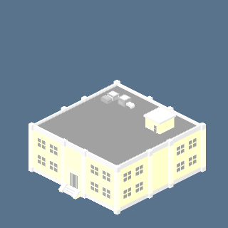 | free_mini.glb: m2 | APARTMENT:1, QUARTER:1 | 2
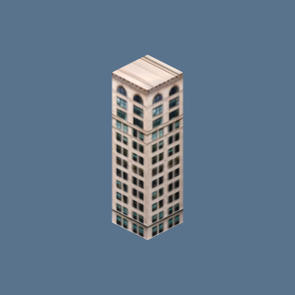 | ny_buildings.glb: ny_brick_1 | APARTMENT:2 | 2
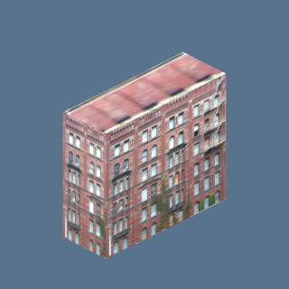 | ny_buildings.glb: ny_brick_5 | APARTMENT:1 | 1
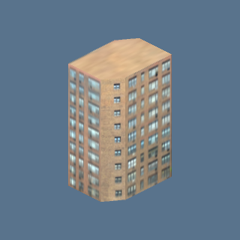 | ny_buildings.glb: ny_brick_6 | APARTMENT:1, COMMERCIAL:1 | 2

CIVIC (41)
Picture | Model | Where | Count
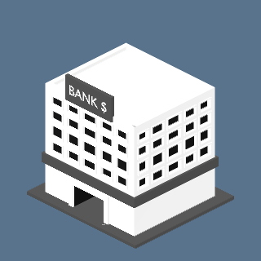 | bank_min.glb: bank_minimalist | CIVIC:1 | 1
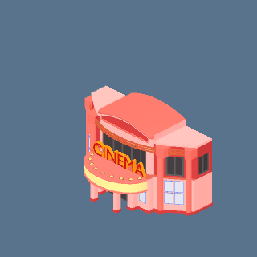 | cinema_night.glb: cinema | CIVIC:1 | 1
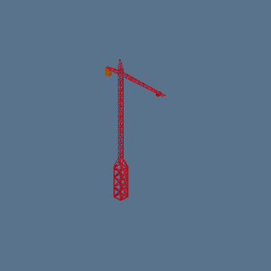 | crane.glb: crane | CIVIC:1, INDUSTRIAL:1 | 2
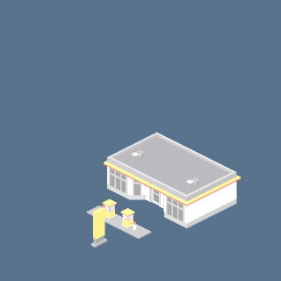 | free_mini.glb: m11 | CIVIC:1 | 1
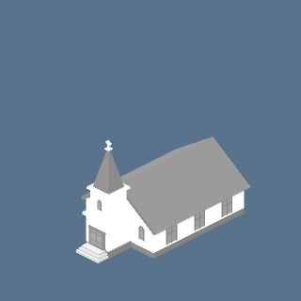 | free_mini.glb: m12 | CIVIC:1 | 1
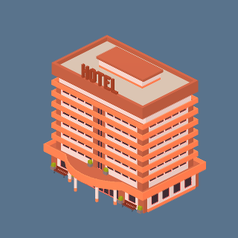 | hotel_low.glb: hotel_orange | CIVIC:1 | 1
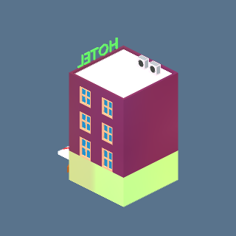 | hotel_small_night.glb: hotel_small | CIVIC:1 | 1
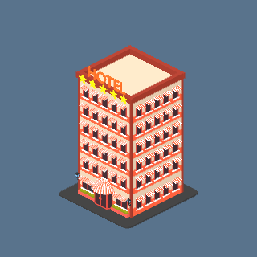 | hotel_stars_night.glb: hotel_stars | CIVIC:1 | 1
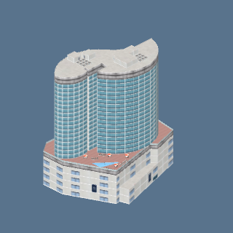 | hotels.glb: hotel_tower | CIVIC:1 | 1
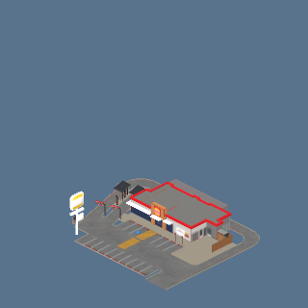 | hungry.glb: burger_king | CIVIC:1 | 1
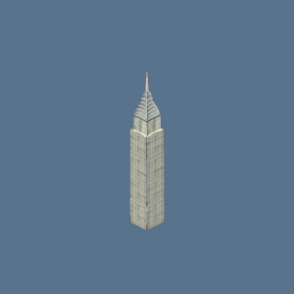 | ny_buildings.glb: chrysler | CIVIC:1 | 1
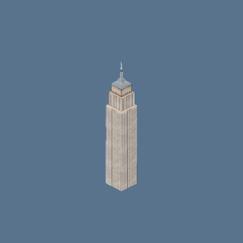 | ny_buildings.glb: empire_state | CIVIC:1 | 1
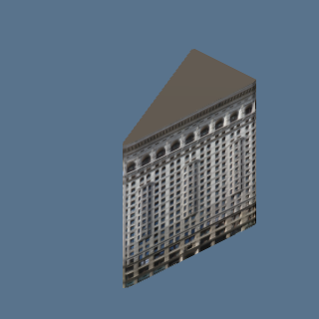 | ny_buildings.glb: flatiron | CIVIC:1 | 1
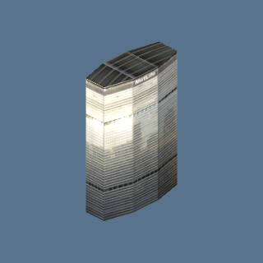 | ny_buildings.glb: metlife | CIVIC:1 | 1
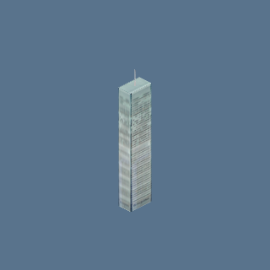 | ny_buildings.glb: ny_times | CIVIC:1 | 1
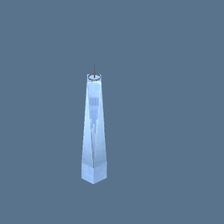 | ny_buildings.glb: one_wtc | CIVIC:1 | 1
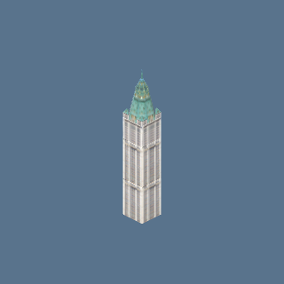 | ny_buildings.glb: woolworth | CIVIC:1 | 1
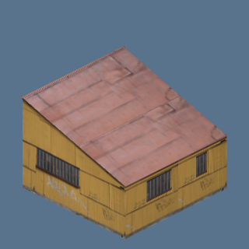 | outpost.glb: barrack_b | CIVIC:1, DESERT:1 | 2
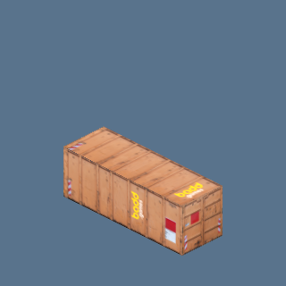 | outpost.glb: container | CIVIC:1 | 1
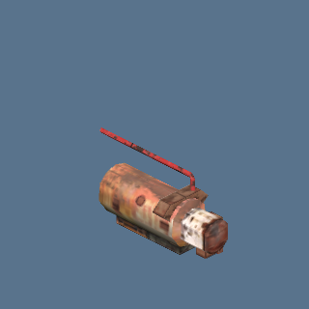 | outpost.glb: generator | CIVIC:1 | 1
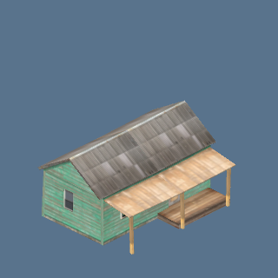 | outpost.glb: ranch_a | CIVIC:1 | 1
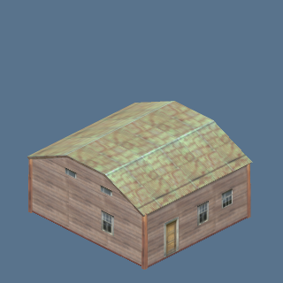 | outpost.glb: ranch_b | CIVIC:1 | 1
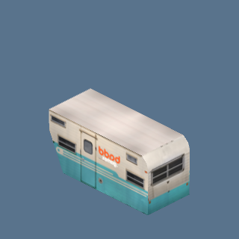 | outpost.glb: trailer_a | CIVIC:1 | 1
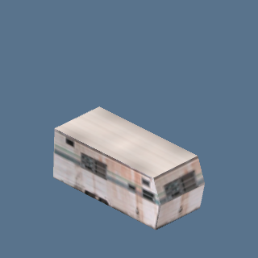 | outpost.glb: trailer_b | CIVIC:1, DESERT:1 | 2
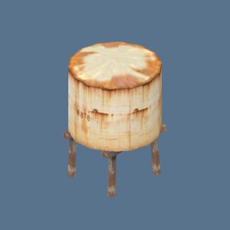 | outpost.glb: water_tank | CIVIC:1 | 1
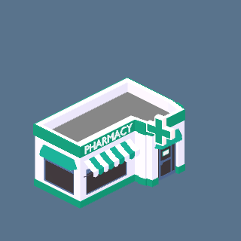 | pharmacy_night.glb: pharmacy | CIVIC:2 | 2
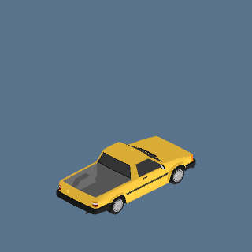 | Pickup (Mustard) (m8_pickup_mustard) | CIVIC:1 | 1
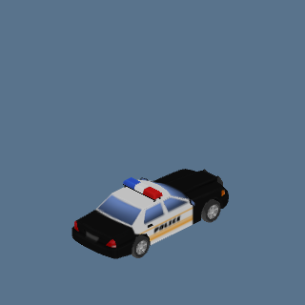 | Police car (US) (Black and white) (police_us_cruiser) | CIVIC:2 | 2
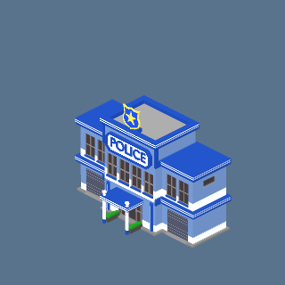 | police_hq_night.glb: police_hq | CIVIC:1 | 1
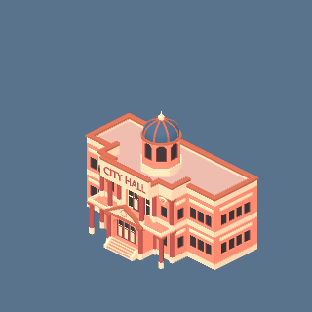 | public_main.glb: city_hall | CIVIC:1 | 1
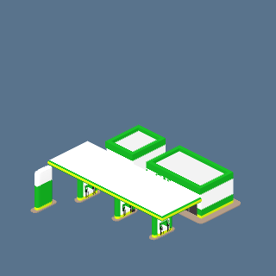 | public_main.glb: gas_station | CIVIC:1 | 1
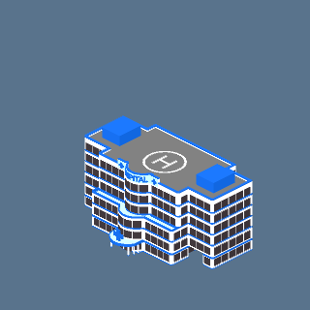 | public_main.glb: hospital | CIVIC:2 | 2
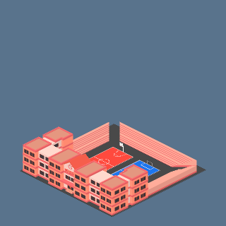 | public_main.glb: school | CIVIC:1 | 1
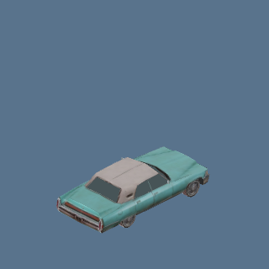 | Sedan (Classic hardtop, teal) (p54_24_sedan_hardtop_teal) | CIVIC:2 | 2
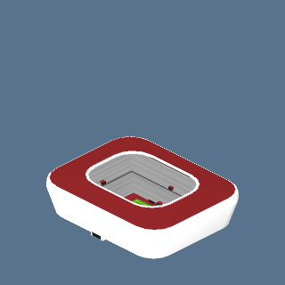 | stadium.glb: stadium | CIVIC:1 | 1
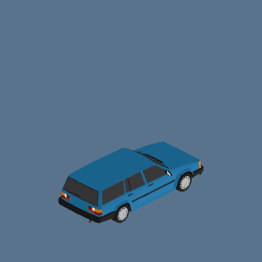 | Station wagon (Blue) (m8_wagon_blue) | CIVIC:1, COMMERCIAL:1 | 2
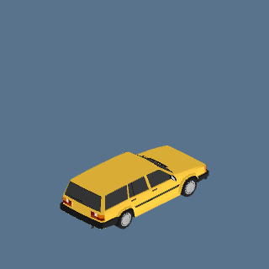 | Station wagon (Mustard) (m8_wagon_mustard) | CIVIC:1 | 1
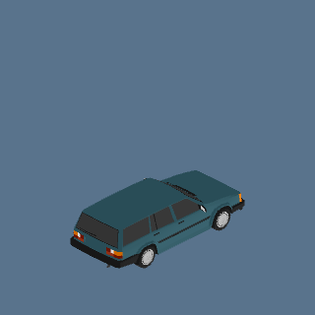 | Station wagon (Teal) (m8_wagon_teal) | CIVIC:1, COMMERCIAL:1 | 2
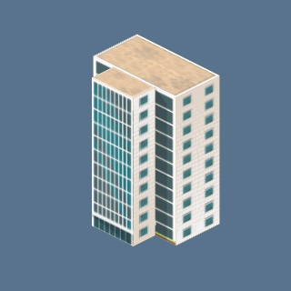 | un_tower.glb: un_tower | CIVIC:1 | 1
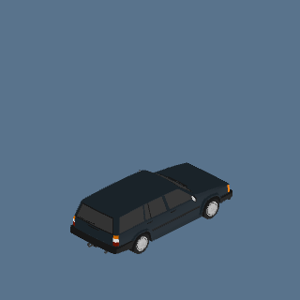 | Wagon, sloped rear (Black) (m8_wagon_sloped_black) | CIVIC:1 | 1
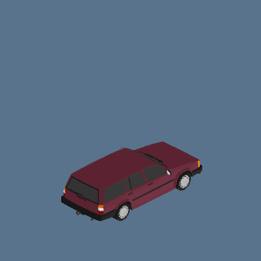 | Wagon, sloped rear (Burgundy) (m8_wagon_sloped_burgundy) | CIVIC:2 | 2

COMMERCIAL (7)
Picture | Model | Where | Count
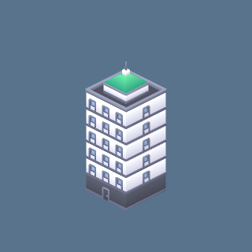 | building-m.glb | COMMERCIAL:1 | 1
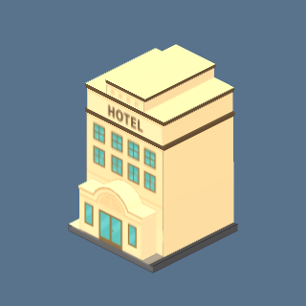 | carto.glb: hotel1 | COMMERCIAL:2 | 2
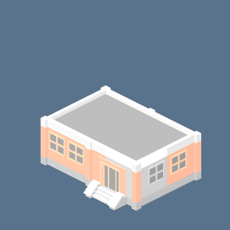 | free_mini.glb: m7 | COMMERCIAL:1, SUBURBAN:1 | 2
 | ny_buildings.glb: ny_brick_6 | APARTMENT:1, COMMERCIAL:1 | 2
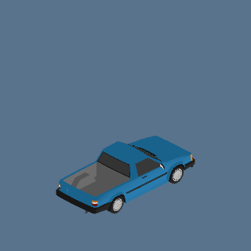 | Pickup (Blue) (m8_pickup_blue) | COMMERCIAL:1 | 1
 | Station wagon (Blue) (m8_wagon_blue) | CIVIC:1, COMMERCIAL:1 | 2
 | Station wagon (Teal) (m8_wagon_teal) | CIVIC:1, COMMERCIAL:1 | 2

DESERT (6)
Picture | Model | Where | Count
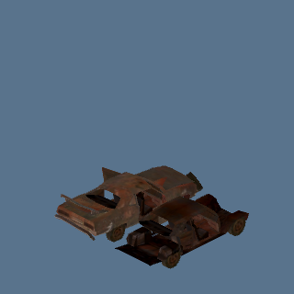 | Chassis wreck (Rusted frame) (p54_12_wreck_chassis) | DESERT:1 | 1
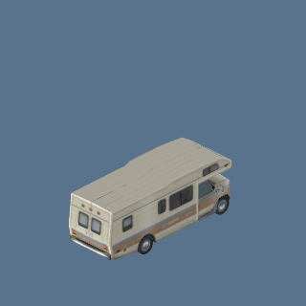 | Motorhome (Class A, beige) (p54_31_rv_class_a_beige) | DESERT:1 | 1
 | outpost.glb: barrack_b | CIVIC:1, DESERT:1 | 2
 | outpost.glb: trailer_b | CIVIC:1, DESERT:1 | 2
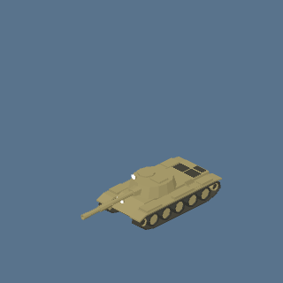 | tank.glb: tank | DESERT:1 | 1
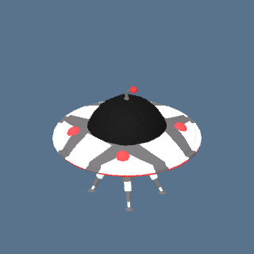 | ufo.glb: ufo | DESERT:1 | 1

DOWNTOWN (10)
Picture | Model | Where | Count
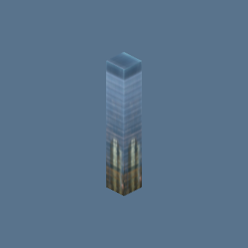 | ny_buildings.glb: ny_glass_1 | DOWNTOWN:1 | 1
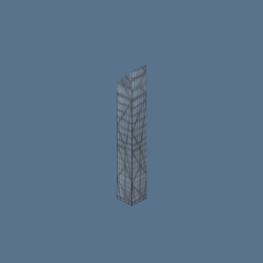 | ny_buildings.glb: ny_glass_2 | DOWNTOWN:1 | 1
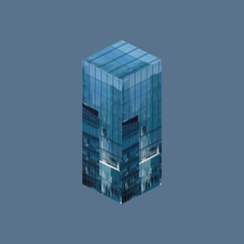 | ny_buildings.glb: ny_glass_4 | DOWNTOWN:2 | 2
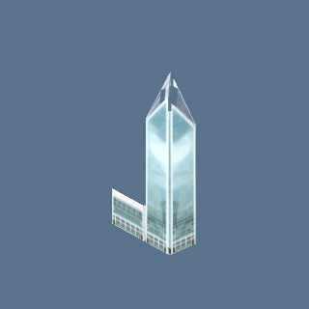 | towers_a.glb: towers_a_11_b | DOWNTOWN:2 | 2
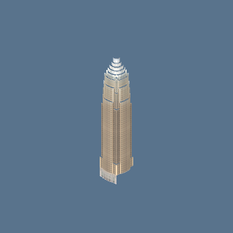 | towers_a.glb: towers_a_17_b | DOWNTOWN:2 | 2
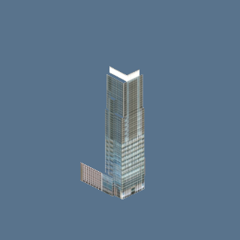 | towers_a.glb: towers_a_33_b | DOWNTOWN:1 | 1
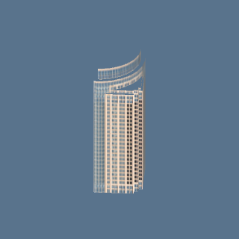 | towers_a.glb: towers_a_46_b | DOWNTOWN:1 | 1
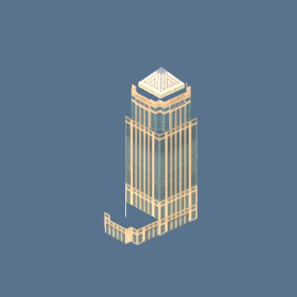 | towers_a.glb: towers_a_51_b | DOWNTOWN:1 | 1
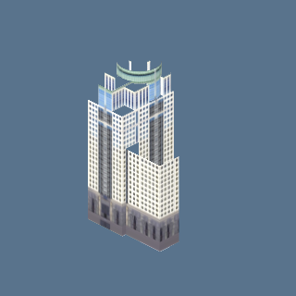 | towers_a.glb: towers_a_75_b | DOWNTOWN:1 | 1
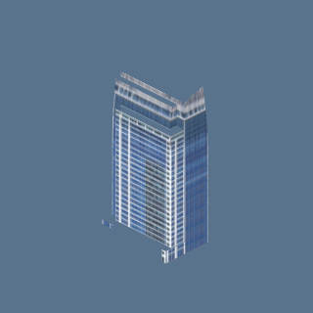 | towers_a.glb: towers_a_83_b | DOWNTOWN:1 | 1

FARM (5)
Picture | Model | Where | Count
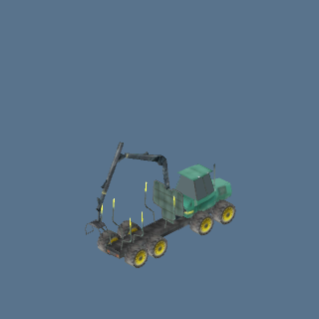 | Forwarder (Timber, green) (p54_42_forwarder_green) | FARM:1 | 1
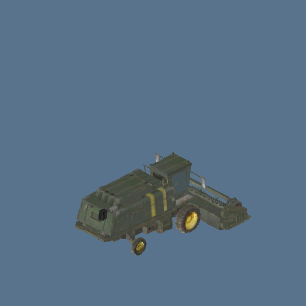 | Harvester (Olive green) (p54_21_harvester_olive) | FARM:2 | 2
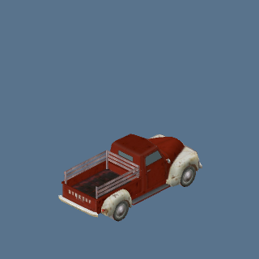 | Pickup (1940s style, red) (p54_26_pickup_40s_red) | FARM:1 | 1
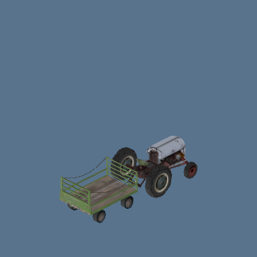 | Tractor (Vintage with trailer) (p54_43_tractor_vintage_trailer) | FARM:2 | 2
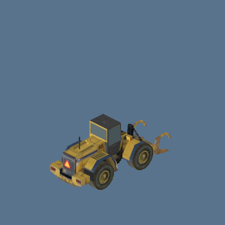 | Wheel loader (Claw bucket, yellow) (p54_41_loader_claw_yellow) | FARM:1 | 1

FOG: ARMY BASE (2)
Picture | Model | Where | Count
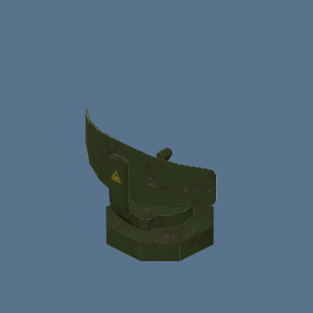 | camp_radar.glb: camp_radar | FOG: ARMY BASE:2 | 2
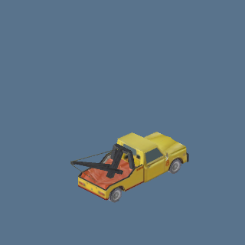 | Tow truck (Yellow) (p54_08_tow_truck_yellow) | FOG: ARMY BASE:1 | 1

FOG: NUCLEAR PLANT (1)
Picture | Model | Where | Count
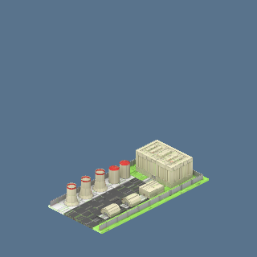 | nuclear2.glb: nuclear2 | FOG: NUCLEAR PLANT:1 | 1

INDUSTRIAL (43)
Picture | Model | Where | Count
 | crane.glb: crane | CIVIC:1, INDUSTRIAL:1 | 2
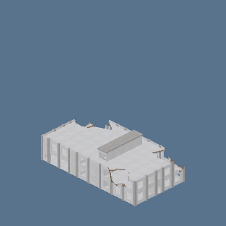 | industrial.glb: ruin | INDUSTRIAL:1 | 1
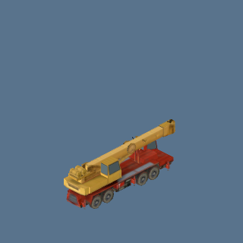 | Mobile crane (Truck-mounted, red/yellow) (p54_35_crane_truck_mobile) | INDUSTRIAL:1 | 1
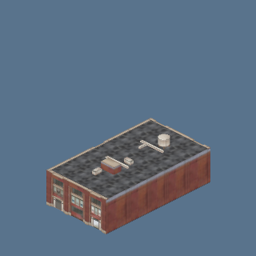 | port_halls.glb: hall_building_1 | INDUSTRIAL:1 | 1
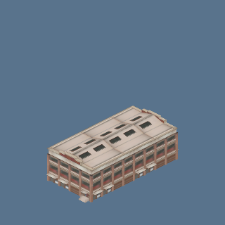 | port_halls.glb: hall_building_10 | INDUSTRIAL:1 | 1
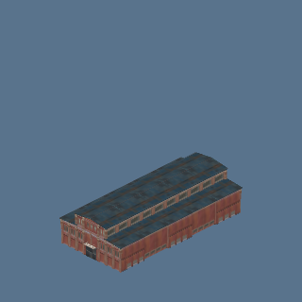 | port_halls.glb: hall_factory_1 | INDUSTRIAL:1 | 1
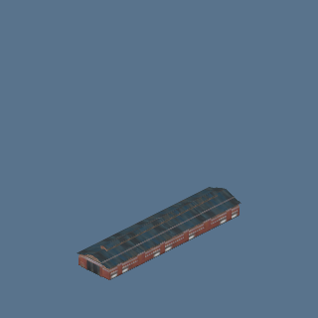 | port_halls.glb: hall_factory_2 | INDUSTRIAL:1 | 1
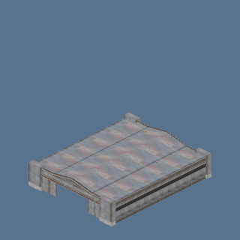 | port_halls.glb: hall_hangar | INDUSTRIAL:1 | 1
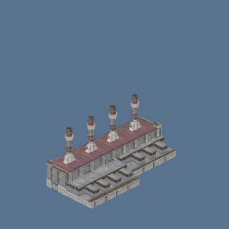 | port_halls.glb: hall_powerplant | INDUSTRIAL:1 | 1
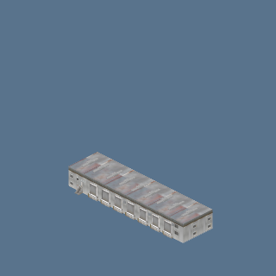 | port_halls.glb: hall_terminal | INDUSTRIAL:1 | 1
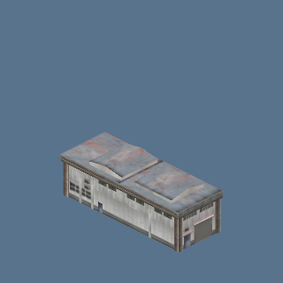 | port_halls.glb: hall_warehouse_1 | INDUSTRIAL:1 | 1
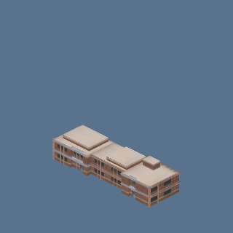 | port_halls.glb: hall_warehouse_4 | INDUSTRIAL:1 | 1
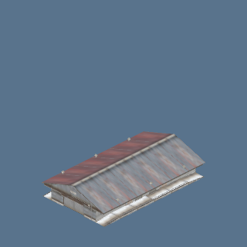 | port_halls.glb: hall_warehouse_5 | INDUSTRIAL:1 | 1
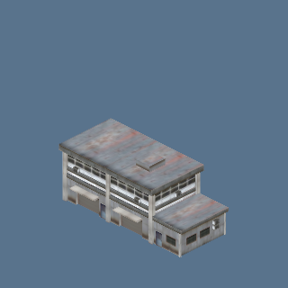 | port_sheds.glb: shed_duplex | INDUSTRIAL:1 | 1
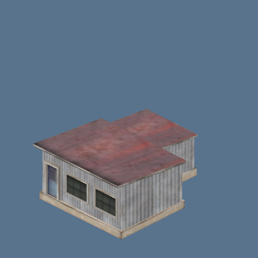 | port_sheds.glb: shed_generic_3 | INDUSTRIAL:1 | 1
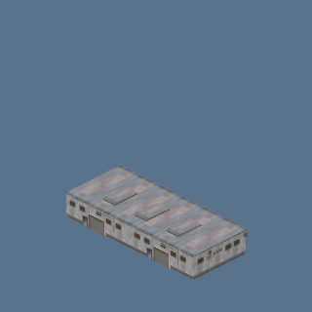 | port_sheds.glb: shed_generic_4 | INDUSTRIAL:1 | 1
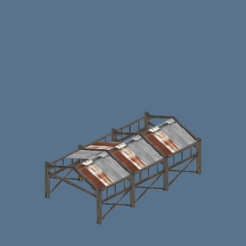 | port_sheds.glb: shed_loadbay | INDUSTRIAL:1 | 1
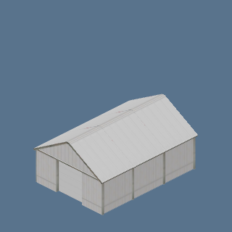 | port_sheds.glb: shed_small_4 | INDUSTRIAL:1 | 1
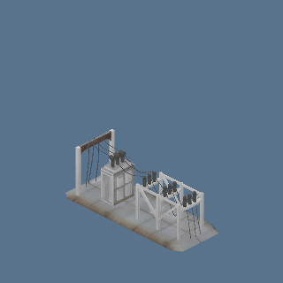 | port_sheds.glb: shed_station | INDUSTRIAL:1 | 1
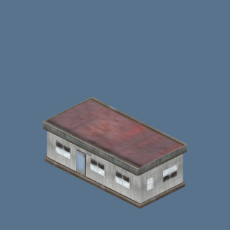 | port_sheds.glb: shed_trailer | INDUSTRIAL:1 | 1
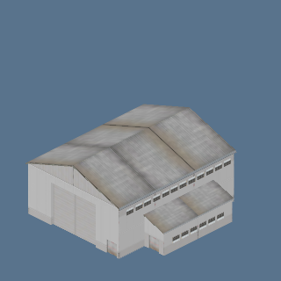 | port_sheds.glb: shed_warehouse_3 | INDUSTRIAL:1 | 1
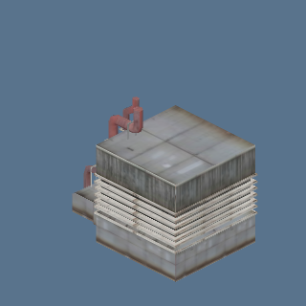 | port_sheds.glb: shed_works_1 | INDUSTRIAL:1 | 1
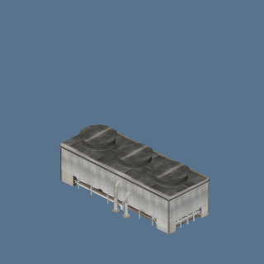 | port_sheds.glb: shed_works_2 | INDUSTRIAL:1 | 1
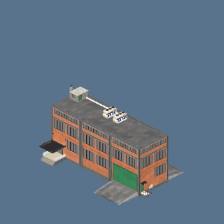 | port_tanks.glb: factory_brick | INDUSTRIAL:1 | 1
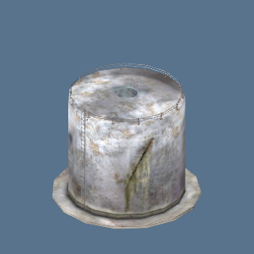 | port_tanks.glb: tank_big | INDUSTRIAL:1 | 1
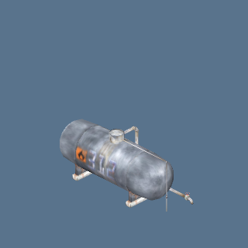 | port_tanks.glb: tank_long | INDUSTRIAL:1 | 1
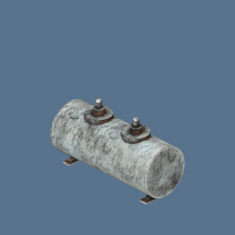 | port_tanks.glb: tank_oil | INDUSTRIAL:1 | 1
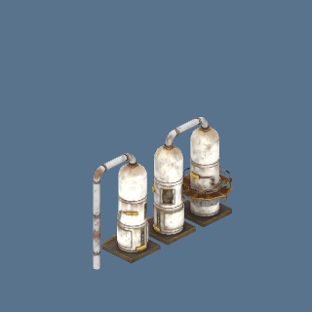 | port_tanks.glb: tank_old | INDUSTRIAL:1 | 1
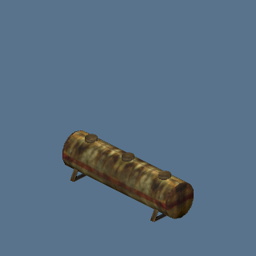 | port_tanks.glb: tank_rusty | INDUSTRIAL:1 | 1
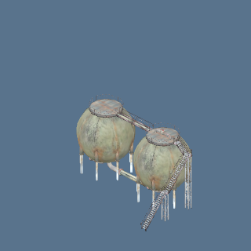 | port_tanks.glb: tank_spheres | INDUSTRIAL:1 | 1
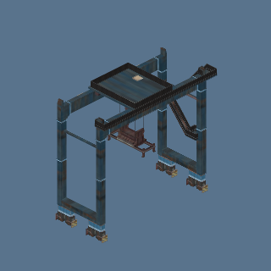 | port_towers.glb: tower_crane | INDUSTRIAL:1 | 1
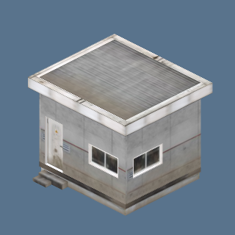 | port_towers.glb: tower_hut | INDUSTRIAL:1 | 1
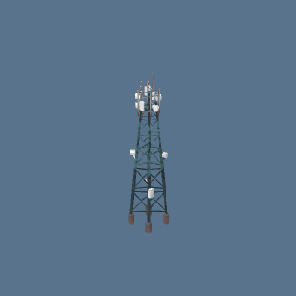 | port_towers.glb: tower_radio | INDUSTRIAL:1 | 1
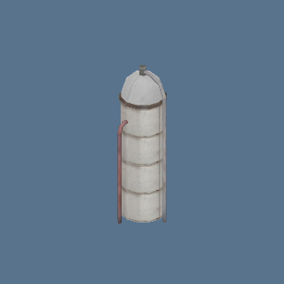 | port_towers.glb: tower_silo | INDUSTRIAL:1 | 1
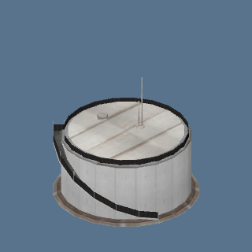 | port_towers.glb: tower_tank_1 | INDUSTRIAL:1 | 1
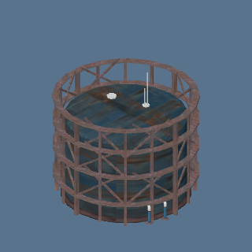 | port_towers.glb: tower_tank_2 | INDUSTRIAL:1 | 1
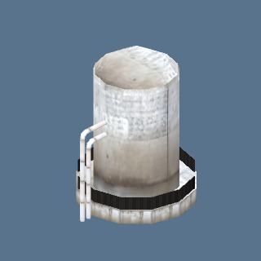 | port_towers.glb: tower_tank_3 | INDUSTRIAL:1 | 1
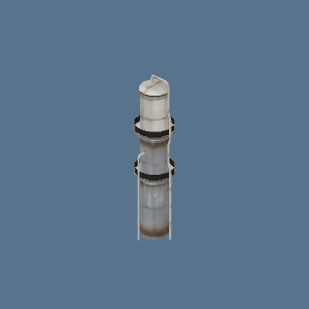 | port_towers.glb: tower_tank_4 | INDUSTRIAL:1 | 1
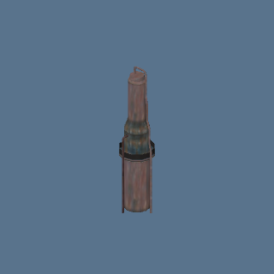 | port_towers.glb: tower_tank_5 | INDUSTRIAL:1 | 1
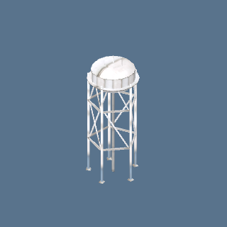 | port_towers.glb: tower_water | INDUSTRIAL:1 | 1
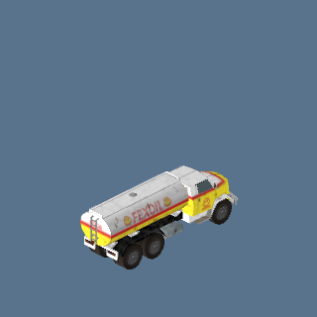 | Tanker (Fuel tanker) (p54_18_tanker_fuel) | INDUSTRIAL:1 | 1
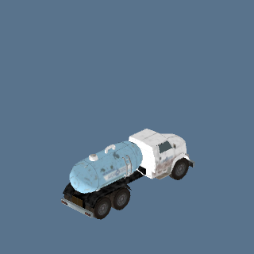 | Tanker (Water tanker) (p54_10_tanker_water) | INDUSTRIAL:1, NATURE:1 | 2
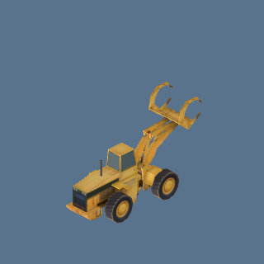 | Wheel loader (Grapple, yellow) (p54_38_loader_grapple_yellow) | INDUSTRIAL:1 | 1

NATURE (7)
Picture | Model | Where | Count
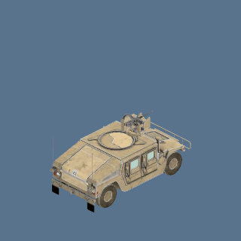 | Armoured vehicle (Humvee, sand) (humvee_sand) | NATURE:1 | 1
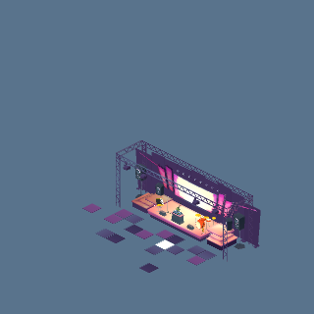 | concert.glb: concert_stage | NATURE:1 | 1
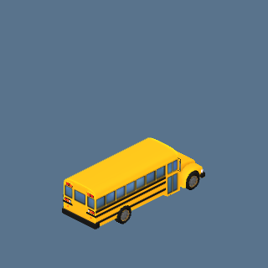 | School bus (Yellow) (school_bus) | NATURE:1 | 1
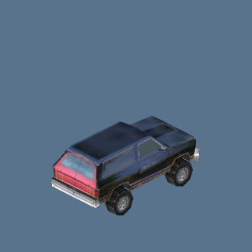 | SUV (Off-road 4x4, navy) (p54_01_suv_offroad_navy) | NATURE:1 | 1
 | Tanker (Water tanker) (p54_10_tanker_water) | INDUSTRIAL:1, NATURE:1 | 2
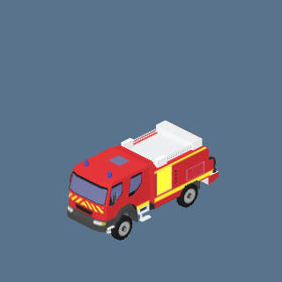 | truck_ccf_night.glb: truck_ccf | NATURE:1 | 1
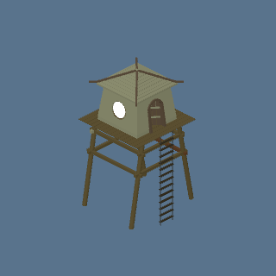 | watchtower.glb: watchtower | NATURE:2 | 2

POOR (6)
Picture | Model | Where | Count
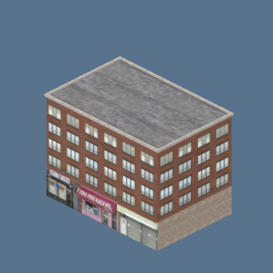 | ny_street.glb: ny_street_05_b | POOR:2 | 2
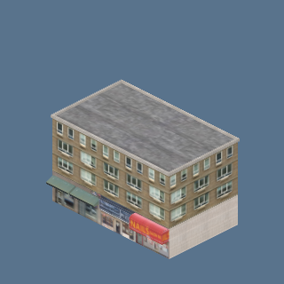 | ny_street.glb: ny_street_08_b | POOR:2 | 2
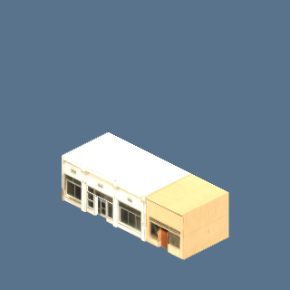 | street.glb: shop_amber | POOR:1, SUBURBAN:1 | 2
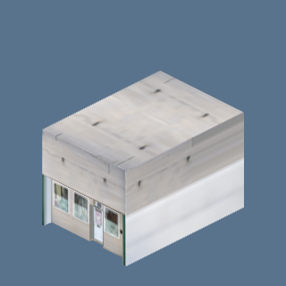 | street.glb: shop_zinc | POOR:1, SUBURBAN:1 | 2
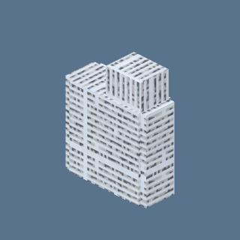 | urban.glb: tower5 | POOR:2 | 2
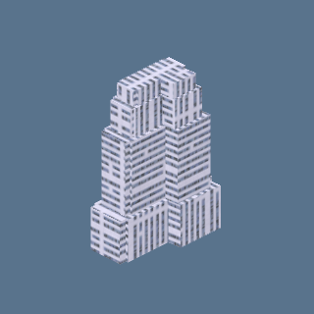 | urban.glb: tower6 | POOR:2 | 2

PRISON (1)
Picture | Model | Where | Count
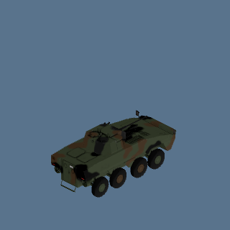 | Rosomak APC (Old version, camo green) (rosomak_apc) | PRISON:1 | 1

QUARTER (18)
Picture | Model | Where | Count
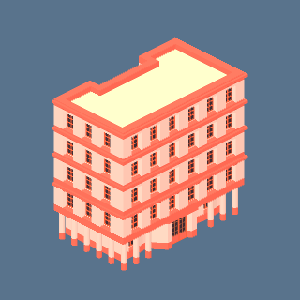 | accommodations.glb: flat10 | QUARTER:2 | 2
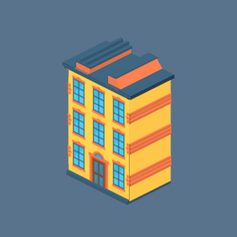 | carto.glb: town1 | QUARTER:1 | 1
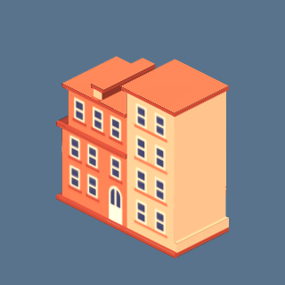 | carto.glb: town2 | QUARTER:1 | 1
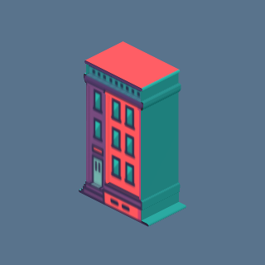 | carto.glb: town7 | QUARTER:1 | 1
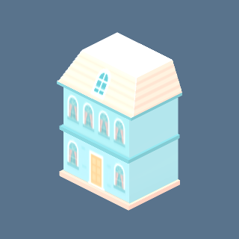 | carto.glb: town8 | QUARTER:2 | 2
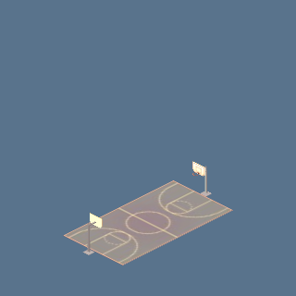 | court.glb: basketball_court | QUARTER:1, SUBURBAN:1 | 2
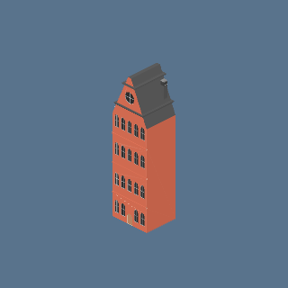 | euro.glb: townhouse_a | QUARTER:1 | 1
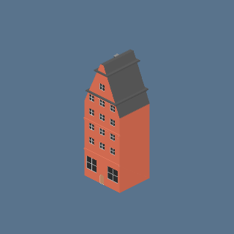 | euro.glb: townhouse_b | QUARTER:1 | 1
 | free_mini.glb: m2 | APARTMENT:1, QUARTER:1 | 2
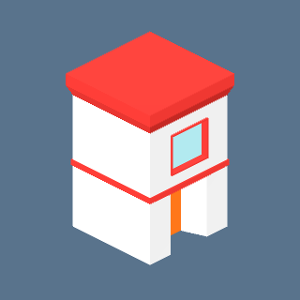 | quarter.glb: quarter_14_b | QUARTER:2 | 2
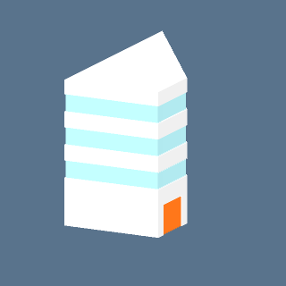 | quarter.glb: quarter_19_b | QUARTER:2 | 2
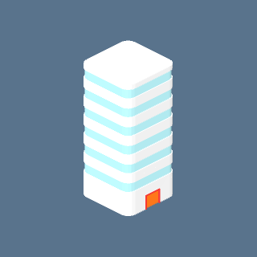 | quarter.glb: quarter_25_b | QUARTER:1 | 1
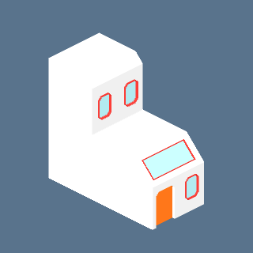 | quarter.glb: quarter_35_b | QUARTER:2 | 2
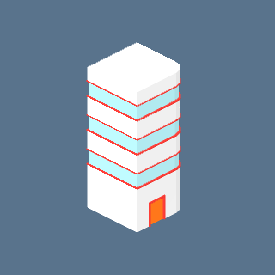 | quarter.glb: quarter_37_b | QUARTER:1 | 1
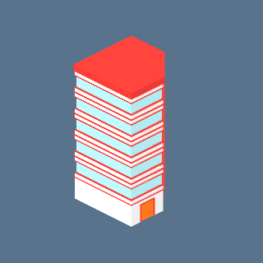 | quarter.glb: quarter_74_b | QUARTER:2 | 2
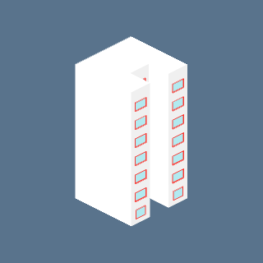 | quarter.glb: quarter_78_b | QUARTER:2 | 2
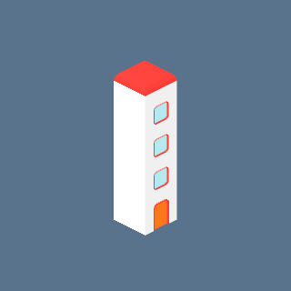 | quarter.glb: quarter_79_b | QUARTER:1 | 1
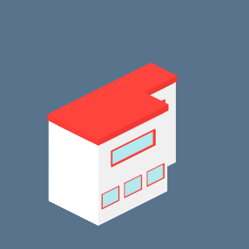 | quarter.glb: quarter_82_b | QUARTER:2 | 2

SEA (3)
Picture | Model | Where | Count
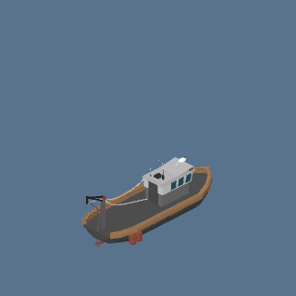 | boat_fishing.glb: boat_fishing | SEA:1 | 1
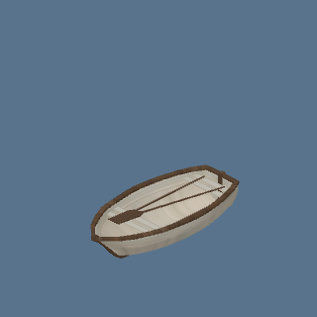 | boat_wooden.glb: boat_wooden | SEA:1 | 1
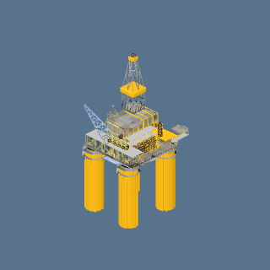 | oil_rig.glb: oil_rig | SEA:1 | 1

SUBURBAN (9)
Picture | Model | Where | Count
 | building-type-f.glb | APARTMENT:1, SUBURBAN:1 | 2
 | building-type-g.glb | APARTMENT:1, SUBURBAN:1 | 2
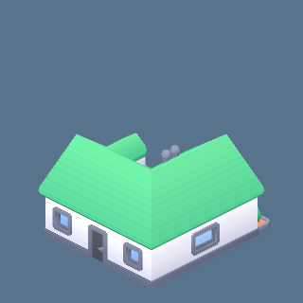 | building-type-m.glb | SUBURBAN:1 | 1
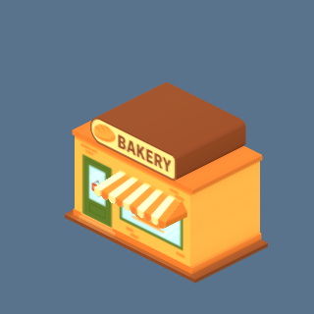 | carto.glb: bakery | SUBURBAN:2 | 2
 | court.glb: basketball_court | QUARTER:1, SUBURBAN:1 | 2
 | free_mini.glb: m7 | COMMERCIAL:1, SUBURBAN:1 | 2
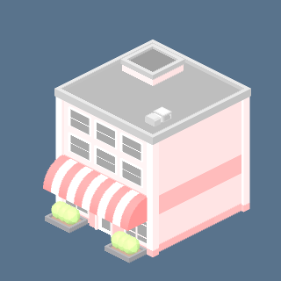 | free_mini.glb: m9 | SUBURBAN:1 | 1
 | street.glb: shop_amber | POOR:1, SUBURBAN:1 | 2
 | street.glb: shop_zinc | POOR:1, SUBURBAN:1 | 2

